BAN240 — CHARACTER SHEET

TUNDE
Tunde · Original Character Profile · Internal Production Document
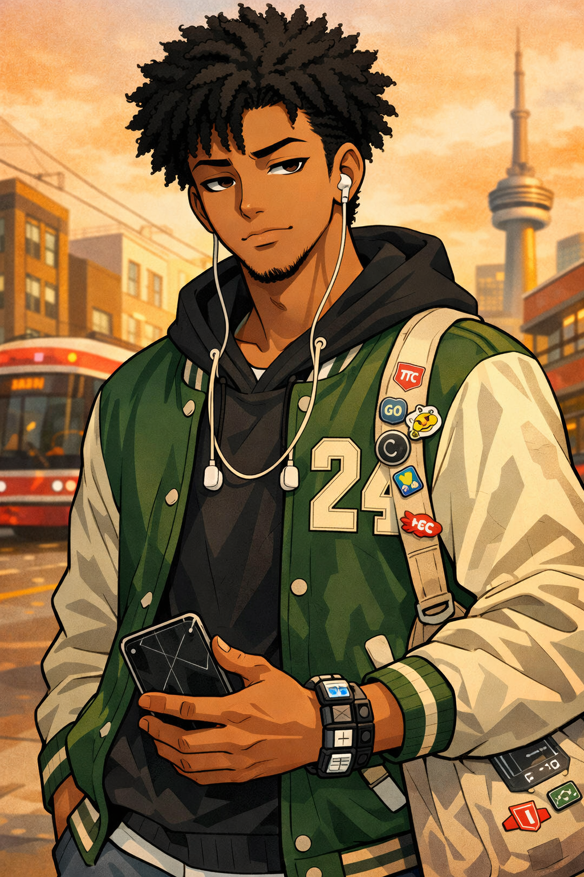

Age | Pronouns | Nationality | City | Sport | Jacket No. | Commute
22 | He/Him | NG-GH-CA | Toronto | Bball | #24 | ~60 min

§01 VISUAL PROFILE & DESIGN NOTES
[ Portrait Placeholder — replace with final linework ] | Portrait Description Tunde is rendered in a clean shōnen-adjacent manga style with bold linework and expressive eyes. He has a tall, athletic build — broad shoulders, long limbs — conveying both physical confidence and restless energy. His skin tone is rendered in warm mid-tone shading. His natural hair is a medium-length, tightly-coiled afro, often slightly unkempt on the sides — a recurring small detail used for comedic timing. His default expression is a half-lidded, unbothered look with one eyebrow slightly raised — a signature "I heard you, I just don't agree" face. His smile, when it appears, is wide and slightly lopsided, full of warmth.

SIGNATURE DESIGN DETAILS
- Jacket: Worn-in varsity-style jacket in forest green and cream, with the number "24" on the back (BAN240 in-universe reference)
- Earbuds: Always hanging around his neck — never fully in his ears
- Bag: Battered canvas tote bag covered in transit stickers and one or two fan pins
- Shoes: Always clean — a deliberate character contrast to the rest of his worn, lived-in wardrobe

§02 DEMOGRAPHICS
Field | Value
Full Name | Adétúndé Afolabi-Mensah
Goes By | Tunde
Age | 22
Birthday | March 14
Pronouns | He/Him
Nationality | Nigerian-Ghanaian Canadian
Hometown | Brampton, ON
Current City | Toronto, ON
Occupation | Part-time warehouse logistics worker; freelance graphic designer (nights & weekends)
Living Situation | Shares a 2-bedroom apartment with a childhood friend in Scarborough
Education | Completed a 2-year design technology diploma; currently undecided about continuing

§03 BIO / BACKSTORY
Tunde grew up the middle child of five in a loud, opinionated household where being heard meant being quick and creative. His father, a civil engineer from Lagos, and his mother, a nurse originally from Accra, gave him a dual-culture upbringing that made him fluent in code-switching — between English, Yoruba phrases, and Twi expressions his cousins taught him. He learned early that humor was armor and that a well-timed comeback could defuse almost anything.
He fell into graphic design almost by accident — doodling in the margins of his high school notebooks led to a Tumblr fan-art account that inexplicably blew up during his senior year. That minor internet moment was enough to convince him to pursue design formally, even if his family initially wanted something "more stable." He's genuinely talented, but still fights impostor syndrome on a daily basis, particularly when comparing his freelance client work to the polished portfolios he sees online.
Tunde is in that particular limbo of early adulthood where he knows exactly who he is but hasn't yet figured out what he's supposed to do with that. He has ambitions — a vague, persistent dream of working on a real manga or animated series — but the gap between here and there feels enormous on most days. He copes through routine, playlists, and the specific comfort of being in motion, which is partly why his daily commute has become a strange kind of meditation for him.
His relationships are loyal and deep, but he's selective. He has maybe four people he'd call real friends, and he tends to express care through actions (showing up, sending memes at the right moment, remembering small details) rather than words.

§04 PERSONALITY & QUIRKS

CORE TRAITS
- Observant to a fault — notices details others miss, often doesn't mention it until much later
- Dry, understated humour — his funniest moments come from total deadpan delivery
- Deeply principled but avoids preachiness — will quietly remove himself from situations he disagrees with rather than argue
- Surprisingly sentimental — keeps ticket stubs, screenshot conversations, saves birthday messages
- Gets mildly competitive at unexpected things — transit trivia, identifying fonts, finishing podcasts first

RECURRING QUIRKS
- Refers to his earbuds as his "force field" — putting them in signals to anyone nearby that he is unavailable
- Always arrives 8–12 minutes early to everything. Considers being on time "basically late."
- Cannot eat while stressed — will skip meals he was looking forward to if the day has gone wrong
- Hums faintly and unconsciously when concentrating — coworkers have learned to read it as a "do not disturb" signal
- Has a strong opinion about every transit line he's ridden and will share it unprompted

§05 HOBBIES & INTERESTS
Hobby | Notes
Graphic Design & Illustration | His craft and main creative outlet; does both commercial client work and personal fan art
Playlist Curation | Takes it seriously — themed playlists for moods, times of day, and transit lines
Reading (Manga & Graphic Novels) | Reads across genres; annotates favourite volumes in pencil
Amateur Urban Photography | Street shots, transit architecture, signage — shot on his phone, edited by eye
Cooking (West African dishes) | Learned from his mother; uses it to decompress after long shifts
Font Collecting | Has an absurd personal archive of free fonts organised by mood category
Transit Spotting | Notes unusual routes, off-peak schedule gaps, and infrastructure quirks — for fun

§06 SPORTS
Category | Details
Primary Sport | Basketball — Recreational league through his teens; still plays pickup games on weekends. Natural point guard: reads the floor well, facilitates play, doesn't need to be the one scoring. His game reflects his personality: collaborative, composed, occasionally frustratingly calm.
Secondary | Track (Sprint) — Ran 100m and 200m competitively in high school. Personal record: 11.4 seconds in the 100m. Stopped competing after graduation but still sprints occasionally just to feel fast.
Follows | NBA — Toronto Raptors (loyal, long-suffering, deeply sentimental about the 2019 championship); Formula 1 — came for the chaos, stayed for the strategy.

§07 FANDOMS & MEDIA DOSSIER
MANGA / ANIME
- Slam Dunk — foundational. Has opinions about the film adaptation.
- Vagabond — the one he calls his favourite when he wants to sound serious
- Blue Period — hit differently than expected; has reread it twice
- Haikyu!! — will not discuss his emotional reaction to the final arc

MUSIC
- Rotates heavily between Afrobeats, UK drill, R&B, and instrumental lo-fi depending on activity
- Current most-played artists: Burna Boy, Knucks, Amaarae, and a rotating cast of SoundCloud producers
- Maintains a running "commute playlist" that he updates every two weeks
GAMES
- Primarily a single-player RPG player — no time for live-service games
- Replaying Persona 5 for the third time; considers it "research"
- Occasional FIFA with his roommate (extremely competitive, will not admit it)
PODCASTS
- Listens to design, culture, and Nigerian/Ghanaian diaspora commentary podcasts
- Finishes episodes faster than anyone he knows and considers this an achievement

§08 DAILY TRANSIT PROFILE
Route Snapshot
Route
Scarborough → Downtown Toronto
Mode
TTC — bus to subway, transfers at Kennedy Station
Avg. Commute Time
52–68 minutes one way
(he tracks this)
Frequency
5 days/week to the warehouse; additional trips for design client meetings

COMMUTE BEHAVIOUR
- Boards the bus at the same stop every morning, stands in the same spot on the platform
- Uses the full commute as designated music/podcast/manga time — phone on Do Not Disturb
- Has strong preferences about which subway car to board based on exit positioning at his destination
- Can name every major delay that's affected his route in the last six months
- Occasionally sketches on his phone (uses a stylus app) during longer legs of the journey

Commute Mood Indicator
The state of Tunde's playlist choice is a reliable emotional barometer — Afrobeats means a good day; instrumental lo-fi means he's processing something; silence means something has gone genuinely wrong.

§09 DESIGN & STORY NOTES
Production Sidebar — For Manga Team Use
• Tunde functions narratively as a grounding presence — the character other cast members orbit when they need a reality check
• His visual signature (the clean shoes vs. everything else) is intentional: it represents the one thing he fully controls in an uncertain life
• The number "24" on his jacket connects to BAN240's in-universe lore — do not change without consulting the series outline
• Avoid portraying him as unambiguously "the wise friend" — his uncertainty and occasional wrong calls are essential to his arc
• His commute scenes are intended as recurring visual interludes — quiet, observational, slice-of-life pacing breaks within larger story arcs

BAN240 Original Character — Tunde | Created for internal production use | All character details subject to revision

